HOMEWORK SUBMISSION PORTAL
@CREATIVITY THINK (9483175986/7019689991)

ABSTRACT:
Homework Submission Portal is a web-based application designed to facilitate the submission, tracking, and feedback of homework for students, tutors, and schools. The system allows students to upload homework assignments, track deadlines, and receive feedback from educators. Administrators can moderate submissions, provide feedback, and analyze submission trends through interactive dashboards. Built with Django and Django Rest Framework for backend operations, and React with Dropzone and Recharts for frontend interactions, the platform ensures an organized, efficient, and transparent homework management process for both users and administrators..

INTRODUCTION OF THE PROJECT:
Traditional homework submission methods often rely on physical submissions or scattered digital communication channels, resulting in missed deadlines, lost assignments, and limited feedback. Homework Submission Portal addresses these challenges by providing a centralized system for submitting, reviewing, and tracking homework. Students have a clear interface to upload assignments and monitor deadlines, while tutors can provide timely feedback and monitor overall performance. The system improves academic workflow, ensures accountability, and enables efficient management of homework submissions..

PROJECT OBJECTIVES:

• Provide a secure platform for students to upload homework
• Track submission deadlines and overdue assignments
• Allow tutors to moderate submissions and give feedback
• Maintain revision history for all homework assignments
• Offer dashboards with analytics for both students and administrators
• Ensure secure storage and retrieval of submitted files
• Enable administrators to monitor trends and generate reports
• Improve academic workflow and accountability

PROBLEM OF THE STATEMENT:
Homework management in schools and online learning environments is often fragmented, relying on multiple tools, emails, or physical hand-ins. This creates challenges in tracking submissions, managing deadlines, providing feedback, and analyzing overall performance. Students may miss deadlines, and educators lack a structured system to manage submissions efficiently. Homework Submission Portal addresses these issues with a unified platform for uploading, tracking, reviewing, and reporting homework activities..

MOTIVATION OF THE PROJECT:
• To centralize homework submission and feedback
• To reduce manual tracking of deadlines and assignments
• To improve transparency and accountability in submissions
• To provide an easy-to-use interface for students and tutors
• To allow educators to provide timely feedback and track revisions
• To enable administrators to analyze performance and submission trends
• To streamline academic operations and enhance learning outcomes

BLOCK DAIGRAM OF PROJECT:

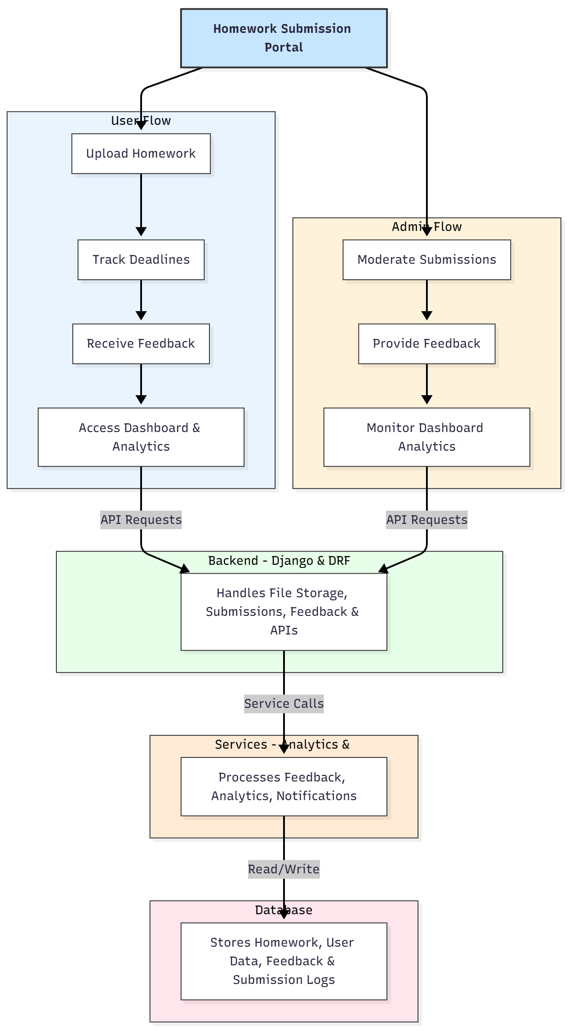

WORKING OF THE PROJECT:
Students begin by uploading homework assignments through the portal, which are securely stored in the backend. The system tracks submission deadlines and notifies students of pending or overdue submissions. Tutors access the portal to moderate submissions, provide feedback, and maintain revision history. Both students and administrators can view interactive dashboards showing submission statistics, feedback summaries, and trends over time. Backend APIs manage file uploads, user authentication, feedback, and analytics processing, while the database ensures secure storage and traceability of all records..

SOFTWARE REQUIREMENT:
- Backend:
  - Python 3.x
  - Django
  - Django REST Framework
  - SQLite/PostgreSQL
- Frontend:
  - Node.js and npm
  - React.js
  - Axios
- Development Tools:
  - Visual Studio Code
  - Postman (for testing APIs)
  - Git/GitHub (for version control)
- Server/Deployment (Optional):
  - Gunicorn, Nginx, or Heroku/AWS for hosting

ADVANTAGES OF THE PROJECT:

• Streamlined homework submission process
• Real-time tracking of deadlines
• Secure and centralized storage of assignments
• Feedback and revision history for accountability
• Dashboard analytics for insights into submissions and performance
• Reduced dependency on manual tracking methods
• Easy access for students, tutors, and administrators
• Scalable for schools and online learning platforms

APPLICATIONS OF THE PROJECT:
• Schools and educational institutions
• Online learning platforms
• Tutors and coaching centers
• Student project submission and tracking
• Academic evaluation and feedback systems

REFERENCES:

- Django REST Framework Documentation — Django Software Foundation. Django Documentation. Available: https://docs.djangoproject.com/
- Django REST Framework. DRF Documentation. Available: https://www.django-rest-framework.org/
- React. React Official Documentation. Available: https://reactjs.org/docs/getting-started.html
- Redux. Redux Documentation. Available: https://redux.js.org/introduction/getting-started
- PostgreSQL Global Development Group. PostgreSQL Documentation. Available: https://www.postgresql.org/docs/
- MySQL. MySQL Reference Manual. Available: https://dev.mysql.com/doc/
- Git. Git Documentation. Available: https://git-scm.com/doc
- Node.js. Node.js Documentation. Available: https://nodejs.org/en/docs/
- Axios. Axios Documentation. Available: https://axios-http.com/docs/intro
- Socket.io Documentation – https://socket.io/docs/

